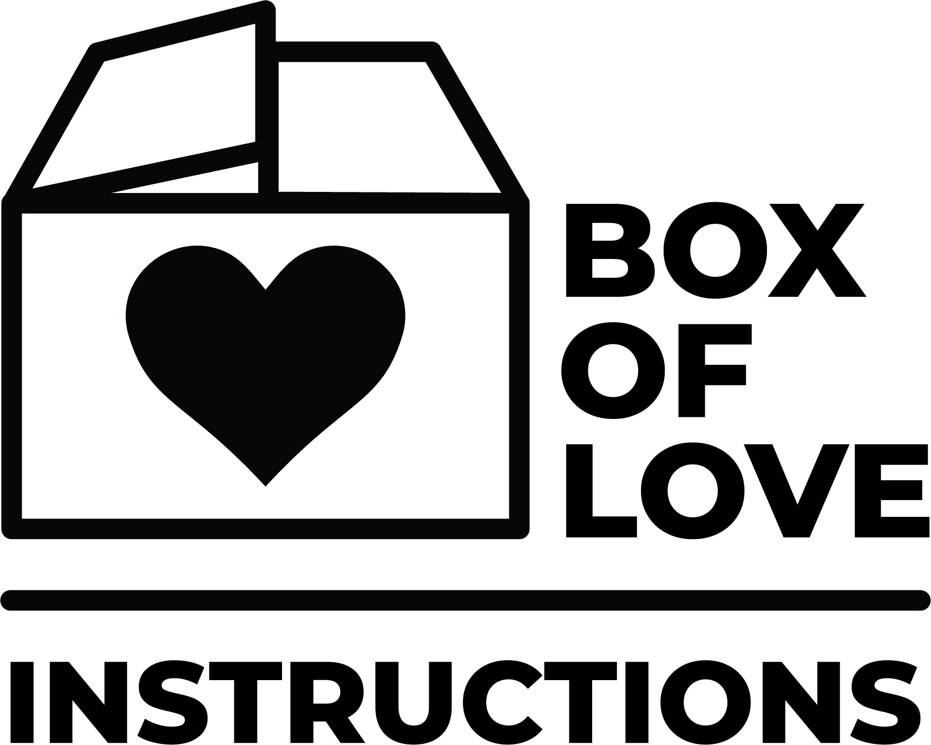

Thank you so much for taking time to show an outward expression of love to a family! Here is what you will need to do to complete your WOW JAM Box of Love.

ASSEMBLING YOUR BOX:
- Purchase the items listed below:
- 2- 16 oz bags of Pinto Beans or (1) 32 oz bag
- 2- 16 oz bags of Rice or (1) 32 oz bag
- 1- Box of Honey Nut Cheerios
- 1- Plastic Bottle of Cooking Oil - 48 oz.
- 1- Box of Pancake Mix (add water only type) 32 oz
- 1- Plastic Bottle of Juice - 64 oz
- 1- Plastic Jar of Peanut Butter - 28 oz
- 2- boxes or bags of Pasta
- 1- Can of Pasta Sauce
Each box should contain the above items. It is important to follow the sizes indicated, as it will ensure that all items will fit inside of the box.

- Write a letter to the family receiving this box.

- Tape the bottom only, leaving the top open.

- Bring your box on a designated day.

DROP OFF DATES:
- Saturday, August 26th (day of picnic)
- Sunday, August 27th
- Wednesday, August 23rd
- Sunday, September 3rd - last day to drop off.

